Subject: August PSAP Pulse
Attachments:
Hello from the GTAC!
Dear PSAP community,
Welcome to this month’s edition of the PSAP Pulse. As usual, we’re sharing the latest resources, upcoming events, and evidence-based strategies to support your work in mental health, substance use, and aging care for older adults. Let’s continue advancing the accessibility of aging in place in our communities!
If you have a testimonial or resource that you would like to share, please send it to NYAM by email at ylei@nyam.org.
Outreach and Engagement Practice Highlight: Key Black Figures in Mental Health
In May, the SAIL’s Aging in Place team presented “Key Black Figures in Mental Health” at Brooks Older Adult Center in recognition of Mental Health Awareness Month. The presentation highlighted eight (8) influential Black individuals who made significant contributions to the mental health field. A particularly impactful component of the presentation was the discussion of the historic Doll Study, which sparked a meaningful conversation among participants about childhood experiences and identity. The team recreated the study by showing images of four dolls of different races and asking clients to share their preferences and reasoning. This prompted a powerful and educational dialogue, with older adults reflecting on growing up in a society where they rarely saw themselves represented in the media or public life. The presentation was created by Azali Cyril, Peer Advocate for SAIL/Aging in Place, and delivered by Maribel Ramos, Peer Advocate Intern. Participants at Brooks Older Adult Center provided positive feedback and expressed appreciation for the thoughtful and engaging presentation.

SAIL’s presentation that provides an example of effective, culturally specific outreach can be accessed on the Resource Library here.

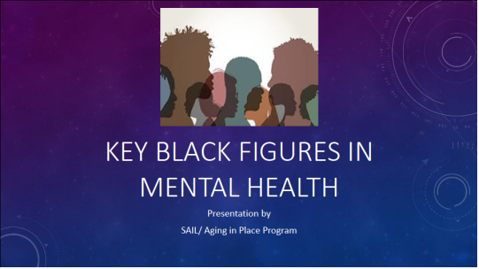

OMH Announcements
OMH Central Office: Responding to cuts under the new federal budget
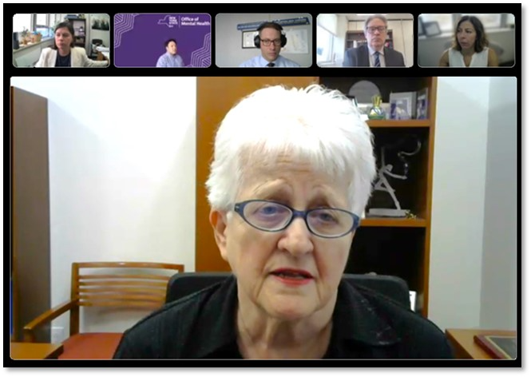

Commissioner Dr. Ann Sullivan and OMH leadership held a video town hall on July 21 for mental health providers and advocates to discuss the impact of recent federal actions and how OMH can provide support during this time.

The Congressional Budget Reconciliation Bill that was signed into law in July has many in New York’s mental health care community anxious as OMH evaluates the impact it will have. OMH already knows that these cuts will have a broad-reaching impact on Medicaid eligibility and funding for programs and institutions that rely on its reimbursements. This will likely have both immediate and long-term consequences for many of the programs OMH oversees.
OMH urges cooperation, focus on strengths
“We’ve encountered formidable challenges before, and we’ve always been able to overcome them by relying on the strength of our collective partnerships,” said OMH Commissioner Dr. Ann Sullivan, in a video town hall on July 21 with mental health providers and advocates.
“Our strength rests in the unrivaled talent and commitment of our agency’s workforce,” she added. “I have full confidence in our ability to continue delivering high-quality mental health care throughout our state.”
She noted that New York State has a champion in Governor Kathy Hochul, who is deeply committed to strengthening our state’s mental health system and to advocating for the rights of all New Yorkers to have access to this care. “Under her leadership, we have seen unprecedented investments in mental health care throughout our state,” the Commissioner said.
“As always, please accept our heartfelt thanks for all that you do and your dedication to the people we serve,” she said. “We’re proud to be standing with you during these uncertain times. I believe we are all stalwart in our commitment to promoting mental health for all New Yorkers and providing hope and recovery for anyone living with mental illness.”
“Together, we will continue valuing diversity and serving our state equitably,” she added. “Most of all, we will continue to support those living with mental illness, their families, our providers, counties, and countless other stakeholders.”
Strategies to minimize impact
Governor Hochul has directed state agencies to prepare comprehensive strategies to help limit the long-term damage to vital programs facing federal cuts. OMH is committed to minimizing the impact to our behavioral healthcare system, provider networks, Local Government Units, and individuals receiving mental health services. It will also seek opportunities to increase efficiency and decrease burdens on our system of care. OMH will soon hold regional planning meetings with counties, providers, advocacy groups, and service recipients to develop strategies for addressing increasing need in response to the changing federal landscape. OMH will also hold meetings for the public to learn more about recent federal developments and potential impacts on OMH programs and funding.
Questions and suggestions can be submitted at any time by e-mail to: planning@omh.ny.gov.
Joining the state’s legal challenges
To date, New York State, through the Attorney General’s office, has brought several lawsuits:
- SAMHSA Grants: Challenging the termination of U.S. Substance Abuse and Mental Health Services Administration COVID-related grants, winning a permanent injunction to restore funding.
- Mental Health Research Grants: Suing over National Institutes of Health grant cuts targeting Diversity, Equity, and Inclusion and LGBTQ research, resulting in a court ruling voiding the cuts.
- School Mental Health Services: In July 2025, the Attorney General sued the U.S. Department of Education over the termination of more than $1 billion in school-based mental health funding, arguing it was unlawful and harmful to students.
- Essential Services Grants: In June 2025, part of a challenge of the administration's cuts to billions of dollars in grants supporting law enforcement, environmental protection, food assistance, and other essential services.
- ACA Amendments: In July 2025, challenging the final rule introduced by the Centers for Medicare and Medicaid Services to amend marketplace coverage, including stricter verification requirements for eligibility, shortened open enrollment periods, and eliminating coverage for gender-affirming care as an essential health benefit.
Newsletter Technical Assistance Survey Results
Thank you all for completing our Newsletter Technical Assistance survey. In total, we received 13 complete responses, with at least one response from each PSAP site. Below is a short summary of survey results:

PSAP Pulse Newsletter
Most respondents indicated that the PSAP Pulse newsletter was a manageable length and useful for PSAP sites. There was a slight preference for newsletter frequency to change to quarterly or bimonthly. The most helpful sections were “New and Recent Resources,” “Staff Highlights,” and the “Evaluation and Data Corner.”

Monthly Coaching Calls & Action Items
Over half of respondents found the monthly coaching calls and summary/action items to be beneficial to their team’s operations. These calls and associated documents help teams stay on track and brainstorm solutions to challenges as they arise. Respondents suggested agendas should be sent earlier and for program successes to be highlighted every quarter.

Webinar & Learning Collaborative Topics
The most popular webinar and/or learning collaborative topics from the past year were:
- Role-based roundtables (March 2025 Learning Collaborative)
- WISE-SBIRT & PSAP: Advancing Substance Use Interventions for Older Adults (February 2025 Webinar)
Respondents indicated a preference for future programming to discuss Medicare/Medicaid, program sustainability and funding, client interventions and programs, and workforce challenges.

NYAM & OMH’s Action Items
Based on your feedback, OMH and NYAM will implement the action items below into their operations:
PSAP Pulse Newsletter
- Decrease the frequency of the PSAP Pulse Newsletter from monthly to bimonthly (every other month).
  - The next edition of the PSAP Pulse will be sent in October.
- Maintain the length of current newsletters and continue to provide information about outreach events, resources, webinars, etc.
- Add more information about funding opportunities.
- Within Staff Highlights, outline site-specific interventions/programs/approaches that have been successful.
Monthly Coaching Calls & Action Items
- Maintain the length of summary and action items.
- Share agendas with sites at least 1 day before coaching calls.
- Add agenda item that provides sites the opportunity to highlight stories of case successes.
Webinar & Learning Collaborative Topics
- Expand on opportunities for cross-site collaboration.
  - OMH & NYAM are working on pairing PSAP sites together for this fall’s site-visits to facilitate shared learning.
- Expand on programming focused on Medicare/Medicaid, program sustainability and funding, client interventions and programs, and workforce challenges.
  - The August webinar will focus on Medicare/Medicaid. Please see registration link below.
  - OMH & NYAM are working on September 16th webinar on “Breaking barriers to support aging in place for all,” which will include information on effective outreach across different subpopulations. It will take place from 3:30-4:30PM. Registration links will be sent out soon.
If there is any other feedback you would like to share with OMH and/or NYAM, please don’t hesitate to reach out and email ylei@nyam.org.

New and Recent Resources
NYS Justice Center: Peer Support Professional Boundaries
Peer support workers are individuals who use their lived experience to make a difference in the lives of others. They may share commonalities with individuals receiving services, including:
- Being of similar age
- Utilizing similar support services
- Sharing challenges
Due to their unique role, they may also face uncertainties in maintaining healthy, professional relationships with individuals in care.
NYS Justice Center’s latest blog, “Peer Support: Best Practices for Maintaining Professional Boundaries,” defines the peer support worker's role when caring for an individual receiving services and provides a direct link to the new Professional Boundaries toolkit created specifically for peer support workers. The toolkit includes comprehensive guidance, best practices, sample templates, and more.
Read the Full Post

SPOP: Supporting Older Adults with Behavioral Health Needs Webinar
Date: Thursday, September 18th from 10AM-12PM
Alex Webb, former Program Director of STRIVE, is hosting webinar trainings for those who work with older adults!
SPOP is offering a series of free interactive training webinars for those who work with older adults. Advance registration is now open for the first session on September 18.

SUPPORTING OLDER ADULTS WITH BEHAVIORAL HEALTH NEEDS
Cultural stigma surrounding aging, behavioral health, and substance misuse can make it difficult for providers to identify challenges and connect clients to services. This session will describe and review common behavioral health challenges; identify screening tools and interventions; and teach best practices to enhance support for older adults.

This session is for anyone who works with an older population. CE credit is available for licensed social workers.
About the trainer: Alexandra Webb, LCSW oversees training and education initiatives at SPOP. She is a graduate of Columbia University School of Social Work and attended the NYU School of Professional Studies.
Register

Eye2Eye
Eye2Eye is a free, phone-based, peer support program, designed to assist individuals who are blind or visually impaired.
The program offers:
- Emotional Support
- Community Connection
- Assessments of Needs and Wellbeing
- Peer Support Groups
- Goal Setting
- Information and Resources
- Referrals
- Services for Families and Loved Ones
- Special Program for Older Adults in NYC
Eye2Eye focuses on the shared experience of vision loss as a powerful tool for connection, emotional support, and personal growth. Callers will be matched with trained peer support specialists who are also blind or visually impaired.
Eye2Eye is here to help build resilience, navigate the challenges of vision loss and celebrate victories one step at a time. Our peer support specialists are ready to help.

Contact us: (833) 932-3931 | eye2eye@shp.rutgers.edu
Follow us: Twitter/X: @eye2eyeps | Facebook: Eye2Eye Peer Support

Visit our website to learn more!

Upcoming Technical Assistance and Conferences
August TA Webinar: Medicare Updates for Peer Support: Principal Illness Navigation and Community Health Integration Codes
Dates: August 13, 2025, from 2-3PM
Join Thomas Bane PhD, LMSW, Acting Regional Administrator, from the Centers for Medicare and Medicaid Services (CMS) to learn more about Medicare coverage options for Peer support and case management. This webinar will explore the use of peers in principal illness navigation and case management through community health integration codes relevant to the work of PSAP sites. Attendees will learn about peer support services and pathways for sustaining their services for older adults with mental health and substance use needs. Please see MLN1986542 – Medicare & Mental Health Coverage for additional information.
In preparation for this webinar, we are asking PSAP sites to share successful billing practices and challenges encountered when trying to bill for any Medicare reimbursable for services, including Peer support or care management services, if they apply. By garnering this feedback, we will be able to tailor the webinar presentation to best fit the needs of each PSAP site.
Please submit these by emailing NYAM at ylei@nyam.org.
Register

